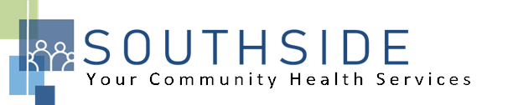

POSITION DESCRIPTION
JOB TITLE: Accounting Manager
REPORTS TO: Executive Director
STATUS: Full-Time, Exempt (salaried)
LOCATION: Dental Clinic
SCHS is a 90-100 employee, full-service, non-profit healthcare clinic serving the needs of the South Minneapolis community. Come make a difference in the lives of people every day. This full-time position will report to the Executive Director and oversee the functions of general ledger and reporting, invoicing and collections, accounts payable and compliance, overseeing a staff of 2. The ideal candidate will have 3-5 years of accounting experience or more and be ready to grow a department. Healthcare accounting experience a plus, but not required.

JOB DUTIES:
- Manage financial accounting functions to ensure timely and accurate reporting of financial information. Develop and implement policies and procedures to ensure compliance with regulatory agencies.
- Review all third-party contracts and monitors contract revenues. Interact with auditors, lenders, and other third-party agencies regarding accounting functions.
- Participate in the internal audit program to ensure internal financial controls. Participate in the annual financial audit and any other special audits.
- Assist in the preparation of financial statistical information and reports for management, government, and other agencies.
- Attend and participate in meetings and committees when required.
- Assist with other duties and responsibilities as assigned.

KNOWLEDGE, SKILLS, AND ABILITIES:

- Knowledge of finance and accounting functions, including budgeting, credit, investments and internal controls.
- Expertise with computer systems, spreadsheet and financial systems programs and applications.
- Understanding of management practices to lead assigned staff. Knowledge of strategic business objectives and employee performance objectives.
- Expertise in analyzing financial data and preparing appropriate related reports.
- Skilled in relating organizational objectives to financial policies on costs, fees, credit, etc.
- Exercise initiative, judgment, discretion and decision-making to achieve organizational objectives.
- Ability to establish and maintain effective working relationships with patients, health care staff, auditors, and the public.
- Skilled in identifying and resolving accounting and financial problems.
- Able to delegate responsibility and authority to staff and work under multiple priorities.
- Work creatively with management and department staff to achieve objectives.
- Communicate effectively and clearly.
- Experience with non-profit organizations a plus, but not required.

MINIMUM QUALIFICATIONS:

- Bachelor’s degree in accounting.
- Minimum three years of accounting experience; healthcare accounting experience desired.

I have read and agree to abide by the job duties indicated above.
_______________________________ _______________________________ _________________
Name Signature Date

