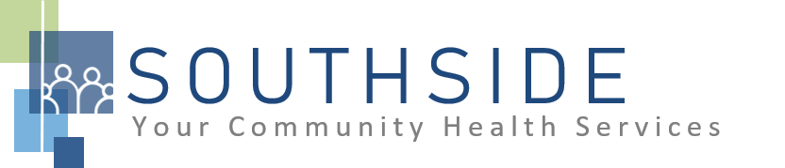
POSITION DESCRIPTION
JOB TITLE: Dental Therapist - Advanced

REPORTS TO: Dental Director and Clinic Manager

STATUS: Exempt (salaried)

LOCATION: Dental Clinic

SCHS is a 90-100 employee, full-service, non-profit healthcare clinic serving the needs of the South Minneapolis community. Come make a difference in the lives of people every day while helping us achieve our mission: To improve the health of our patients and communities by delivering exceptional care, removing barriers, and promoting healthy lifestyles.

ROLE: The Advanced Dental Therapist will provide operational support to ensure that patients receive timely, accurate and quality dental therapy services and treatment, including educational information on proper oral care.

JOB DUTIES:

- Provide skilled dental therapy treatment so clients receive comprehensive dental care. Chart complete and detailed services on all clients at the time of service so that records are kept accurately and legibly.
- Follow established policies and procedures for dental practice to comply with the standard of care established by the MN Board of Dentistry.
- Order necessary radiographs. Clearly document in patient’s chart the type (i.e., bitewing, periapical, etc.) and number of films taken (including retakes).
- Perform initial and periodic charting of the oral cavity, including but not limited to chief complaint, level of patient’s oral hygiene, degree of calculus and plaque, bone loss, and existing restorations.
- Perform full mouth periodontal probing with evaluation of periodontium and dental charting.
- Perform screening procedures including assessment of oral health conditions, oral cancer screening, and head and neck evaluation.
- Attend and participate in staff meetings and committees.
- Assist in daily management and direction of dental personnel.
- Administration of local anesthetic, nitrous oxide; application of desensitizing medication or resin.
- Extracting deciduous teeth and periodontally involved permanent teeth under local infiltration analgesia; undertake routine restorations in both deciduous teeth and permanent teeth on adults and children. Non-surgical extractions of periodontally diseased permanent teeth under general supervision.
- Cavity preparation; placement of fillings (amalgams and resin-based composites).
- Provide dental education to patients, including individualized oral hygiene instruction for proper brushing, flossing and nutritive counseling.
- May provide, dispense and administer analgesics, anti-inflammatories and antibiotics with authorization of a dentist.
- Fill out prior authorizations, referral, and transfer, and nursing home paperwork as needed.
- Follow procedures to maintain infection control following universal and standard precautions.
- Make recommendations regarding equipment and supply needs, monitor inventory of supplies and order when needed. Help with routine maintenance of equipment.
- Maintain licensure and take continuing education courses and CPR training as mandated by the MN board of dentistry.
- Perform all procedures under the advanced dental therapy scope of practice.
- Assist with other duties and responsibilities as reasonably assigned.

KNOWLEDGE, SKILLS, AND ABILITIES:

- Confidence, professional judgment, and grace under pressure.
- Works well both independently and as part of a team.
- Exceptional communication skills.
- Flexibility--nimble in response to an evolving workload.
- Independent, critical thinking; effective problem solving skills.
- Ability to exhibit good rapport with clients of varying ethnic backgrounds and socio-economic status.
- Excellent time management and organizational skills; attention to detail.
- Systematic approach to tasks that ensures consistent output quality.
- Commitment to the SCHS mission and staff values.
- Assist with other duties and responsibilities as assigned.
- Recognize the importance of community service and leadership.
- Exhibit professional growth, self knowledge and lifelong learning strategies.

MINIMUM QUALIFICATIONS:

- Advanced Dental Therapist must have graduated from a dental therapy education program approved by the Board of Dentistry or accredited by the Commission on Dental Accreditation (CODA)
- Must have competency and licensure exam, and jurisprudence exam.
- Current CPR certification.
- Valid and active Minnesota license.
- Licenses and certifications in good standing.
- Bilingual (English/Spanish) preferred; not required.

I have read and agree to abide by the job duties indicated above.
_______________________________ _______________________________ _________________
Name Signature Date

