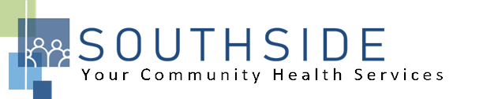
POSITION DESCRIPTION
JOB TITLE: Dental Sterilization Assistant
REPORTS TO: Dental Clinic Manager
STATUS: Non-Exempt (hourly)
LOCATION: Dental Clinic
SCHS is a 90-100 employee, full-service, non-profit healthcare clinic serving the needs of the South Minneapolis community. Come make a difference in the lives of people every day while helping us achieve our mission: To improve the health of our patients and communities by delivering exceptional care, removing barriers, and promoting healthy lifestyles.

ROLE: This position performs and participates in decontamination, cleaning, assembling, packaging, scanning, sterilization, storage and distribution of reusable surgical instruments and equipment to ensure high-quality service to patients.
JOB DUTIES:
- Decontaminate and sterilize instruments, medical supplies and equipment, and assemble, wrap and sterilize trays of instruments. Follow proper standard precautions while in decontamination and sterilization areas; maintain a clean work area.
- Collect, catalog and clean surgical tools following use; inspect for wear or damage.
- Set up trays for dental treatment.
- Follow procedures to maintain infection control.
- Assist in maintaining dental equipment.
- Inventory and store dental equipment and instruments/order supplies as needed.
- Perform daily, weekly, monthly maintenance chores.
- Communicates appropriately using good interpersonal skills, maintains confidentiality of personal health information.
- Attend and participate in staff meetings and committees.
- Assist with other duties and responsibilities as assigned.
KNOWLEDGE, SKILLS, AND ABILITIES:
- Confidence, professional judgment, and grace under pressure.
- Works well both independently and as part of a team.
- Exceptional communication skills.
- Flexible to respond to an evolving workload.
- Ability to exhibit good rapport with clients of varying ethnic backgrounds and socio-economic status.
- Excellent time management and organizational skills.
- Attention to detail.
- Commitment to the SCHS mission and staff values.

MINIMUM QUALIFICATIONS:
- High school diploma or equivalent.
- CPR Certification.
- Bilingual (English/Spanish) preferred.

I have read and agree to abide by the job duties indicated above.
_______________________________ _______________________________ _________________
Name Signature Date
.

