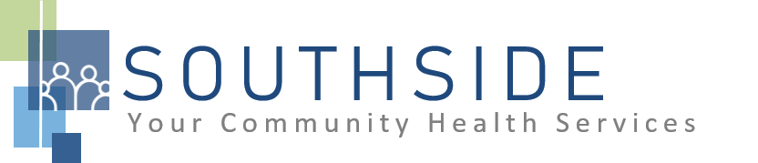
POSITION DESCRIPTION
JOB TITLE: Registered Dental Assistant
REPORTS TO: Dental Director and Dental Clinic Manager
STATUS: Non-Exempt (hourly)
LOCATION: Dental Clinic
SCHS is a 90-100 employee, full-service, non-profit healthcare clinic serving the needs of the South Minneapolis community. Come make a difference in the lives of people every day while helping us achieve our mission: To improve the health of our patients and communities by delivering exceptional care, removing barriers, and promoting healthy lifestyles.

ROLE: This position assures high-quality customer/patient service, quality dental care and administrative support. Responsible to provide chair-side support to the dentists, hygienists and therapists providing primary care dental services to patients.
JOB DUTIES:
- Prepare clients and treatment operatory for dental service.
- Review client’s medical history.
- Assist with charting.
- Assist dentist chair-side with all dental procedures.
- Assist with informed consent.
- Set up trays for dental treatment.
- Perform expanded duties as required; child prophies, placing sealants, take radiographs as prescribed, place and remove rubber damns, etc.
- Follow procedures to maintain infection control.
- Stock and clean dental operatory.
- Wrap and sterilize dental instruments.
- Assist in maintaining dental equipment.
- Inventory and store dental equipment and instruments/order supplies as needed.
- Maintain registration by keeping up to date with necessary continuing education requirements.
- Perform daily, weekly, monthly maintenance chores.
- Attend and participate in staff meetings and committees.
- Aid in training and supervision of dental assisting students and new assistants.
- Cross train with receptionist position to answer phones, check in patients, assist with patient registration paperwork, confirm appointments, scan documents into the patient chart, upload radiographs into the patient chart, all while maintaining patient privacy.
- Assist with other duties and responsibilities as assigned.
KNOWLEDGE, SKILLS, AND ABILITIES:
- Confidence, professional judgment, and grace under pressure.
- Works well both independently and as part of a team.
- Exceptional communication skills.
- Flexibility--nimble in response to an evolving workload.
- Ability to exhibit good rapport with clients of varying ethnic backgrounds and socio-economic status.
- Excellent time management and organizational skills.
- Attention to detail.
- Commitment to the SCHS mission and staff values.

MINIMUM QUALIFICATIONS:
- Diploma or degree in Dental Assisting.
- Registered as a dental assistant in Minnesota.
- Current licensure in Minnesota in good standing.
- CPR Certification.
- Experience in dental scheduling using the Dentrix electronic dental records system.
- Bilingual (English/Spanish) preferred.

I have read and agree to abide by the job duties indicated above.
_______________________________ _______________________________ _________________
Name Signature Date
.

