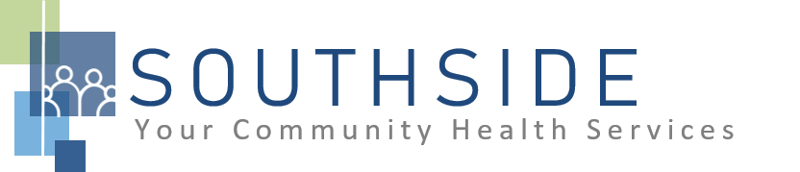
POSITION DESCRIPTION
JOB TITLE: Dental Receptionist/Call Center
REPORTS TO: Dental Clinic Manager (and works closely with Front Office Lead)
STATUS: Non-Exempt (hourly)
LOCATION: Dental Clinic
SCHS is a 90-100 employee, full-service, non-profit healthcare clinic serving the needs of the South Minneapolis community. Come make a difference in the lives of people every day while helping us achieve our mission: To improve the health of our patients and communities by delivering exceptional care, removing barriers, and promoting healthy lifestyles.

ROLE: This position exists to ensure efficient patient flow and excellent customer service, to provide clients with information regarding appointments and services and to ensure prompt collection of fees at the time of service.
JOB DUTIES:
- Answer the telephone during clinic hours, provide information and/or take messages as appropriate.
- Schedule and confirm dental appointments; assure patient flow is moving at required pace. Able to identify patient needs to ensure appropriate scheduling of appointments.
- At least 24 hours prior to patient appointment, ensure pre-visit process is followed.
- Greet patients and update registration information at time of visit; assist new patients when necessary in completing registration forms.
- Assign established charges to provider activities; total account balances and collect payments for services rendered at time of visit.
- Verify insurance information prior to visit and upon registration/check-in; identify opportunities when a patient may benefit from meeting with enabling services (Patient Advocate); assure charge sheet information is complete before turning over to billing clerk.
- Serve and participate as requested in staff meetings, continuous quality improvement, and other process development opportunities within the organization.
- Ensure that the front office area is kept clean and orderly.
- Assist with any interpreting, if needed.
- Call Center staff works on the Mail Return work queue list from EPIC.

- Call Center staff contacts in-house patient referrals to schedule appointments and track the dental referral.
- Assist with other duties and responsibilities as assigned.

KNOWLEDGE, SKILLS, AND ABILITIES:
- Confidence, professional judgment, and grace under pressure.
- Works well both independently and as part of a team.
- Exceptional customer service and communication skills.
- Flexibility--nimble in response to an evolving workload.
- Ability to exhibit good rapport with clients of varying ethnic backgrounds and socio-economic status.
- Ability to work in a fast-paced environment and manage multiple tasks without feeling overwhelmed.
- Excellent time management and organizational skills.
- Attention to detail.
- Commitment to the SCHS mission and staff values.

MINIMUM QUALIFICATIONS:
- Training as a dental assistant or receptionist and experience in scheduling dental appointments.
- Bilingual (English/Spanish) preferred.
- Good computer skills.

I have read and agree to abide by the job duties indicated above.
_______________________________ _______________________________ _________________
Name Signature Date

