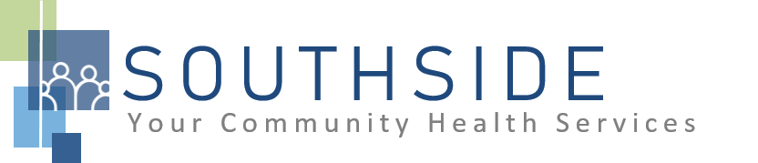
POSITION DESCRIPTION
JOB TITLE: Dentist

REPORTS TO: Dental Director and Clinic Manager

STATUS: Exempt (salaried)

LOCATION: Dental Clinic

SCHS is a 90-100 employee, full-service, non-profit healthcare clinic serving the needs of the South Minneapolis community. Come make a difference in the lives of people every day while helping us achieve our mission: To improve the health of our patients and communities by delivering exceptional care, removing barriers, and promoting healthy lifestyles.

ROLE: The Dentist will provide leadership, implementation, and operational support to ensure that patients receive timely, accurate and quality dental care, including educational information on proper oral care. This position requires travel. Patient care primarily provided in our Mobile Dental Clinic (70% of time). Remainder of patient care completed at onsite Dental Clinic (30% of time).

JOB DUTIES:

- Provide skilled dental treatment so clients receive comprehensive dental care. Chart complete and detailed services on all clients at the time of service so that records are kept accurately, and legibly.
- Follow established policies and procedures for dental practice to comply with the standard of care established by the MN Board of Dentistry. Participate in quarterly peer review audits.
- Establish consulting relationships with dental specialists so that clients receive the benefits of services not provided by the clinic.
- Provide dental education to clients or community groups as requested.
- Attend and participate in staff meetings and committees.
- Assist in daily management and direction of dental personnel.
- Assist with other duties and responsibilities as reasonably assigned.

KNOWLEDGE, SKILLS, AND ABILITIES:

- Confidence, professional judgment, and grace under pressure.
- Leadership skills.
- Works well both independently and as part of a team.
- Exceptional communication skills.
- Flexibility--nimble in response to an evolving workload.
- Independent, critical thinking.
- Ability to exhibit good rapport with clients of varying ethnic backgrounds and socio-economic status.
- Excellent time management and organizational skills.
- Systematic approach to tasks that ensures consistent output quality.
- Attention to detail.
- Commitment to the SCHS mission and staff values.
- Assist with other duties and responsibilities as assigned.

MINIMUM QUALIFICATIONS:

- DDS/DMD and graduate of an accredited school of dentistry.
- Valid and active Minnesota license and DEA Controlled Substance Registration Certificate.
- Licenses and certifications in good standing.

I have read and agree to abide by the job duties indicated above.
_______________________________ _______________________________ _________________
Name Signature Date

