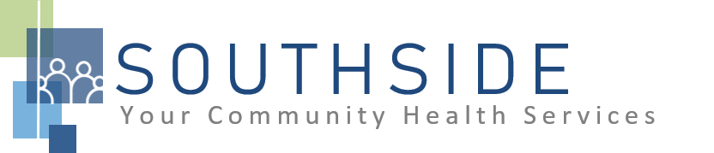
POSITION DESCRIPTION
JOB TITLE: Dental Director
REPORTS TO: Executive Director
STATUS: Exempt (Salaried)
LOCATION: Dental Clinic
SCHS is a 90-100 employee, full-service, non-profit healthcare clinic serving the needs of the South Minneapolis community. Come make a difference in the lives of people every day while helping us achieve our mission: To improve the health of our patients and communities by delivering exceptional care, removing barriers, and promoting healthy lifestyles.

ROLE: This position provides clinical leadership of the dental clinic and ensures high quality care for SCHS patients. Supervises Dentists and Therapists, provides clinical direction to Hygienists, and Dental Assistants. Collaborates with the Dental Clinic Manager and other leaders to ensure the effective management of the dental clinic. This highly visible role will be responsible for regulatory and compliance related matters and work closely with the Director of Quality.
JOB DUTIES:
- Provide skilled treatment and holistic dental care to patients. Chart complete and detailed services on all patients at the time of service so that records are kept accurately and legibly.
- Develop, review and enforce clinical policies and procedures for dental practice to comply with the minimum standards set by the MN Board of Dentistry, OSHA and BPHC/HRSA. Retain current dental manual documenting protocols, policies and procedures. Direct quarterly peer review audits.
- In collaboration with the dental clinic manager, establish consulting relationships with external dental specialists to broaden the scope of services SCHS is able to provide our patients.
- Recruit, hire, train and supervise providers. Provide input and daily work direction to auxiliary staff in collaboration with the clinic manager.
- Define provider scheduling procedures in collaboration with the clinic manager to ensure patients will be served efficiently, professionally and in accordance with best practice standards.
- Support the preparation of the annual financial budget for the dental department. Collaborates with the dental clinic manager to monitor and control expenses, staffing ratios, and production levels.
- Provide oversight of dental education to patients and community groups to optimize preventive measures, develops community dental health initiatives and implements dental health grants.
- Collaborate with the Executive Director relative to clinic initiatives, capital needs, and clinical policies.
- Provide input into the establishment of dental fees and collection policies in conformance with HRSA and related grant requirements. Monitors and manages monthly financial reports as directed by Finance to ensure a strong financial condition of the dental clinic.
- Attend management team meeting and assist clinic manager with dental staff meetings. Provide input into the development of and supports organization strategic initiatives. Serve as a catalyst for clinical providers to know, understand and support organization initiatives. Support organization initiatives such as Meaningful Use and champion such initiatives amongst clinic providers.
- Establish consulting relationships with dental specialists so that clients receive the benefits of services not provided by the clinic.
- Provide dental education to clients or community groups as requested.
- Attend and participate in staff meetings and committees.
- Assist with other duties and responsibilities as assigned.
KNOWLEDGE, SKILLS, AND ABILITIES:
- Confidence, professional judgment, and grace under pressure.
- Leadership skills.
- Works well both independently and as part of a team.
- Exceptional communication skills.
- Flexibility--nimble in response to an evolving workload.
- Independent, critical thinking.
- Ability to exhibit good rapport with clients of varying ethnic backgrounds and socio-economic status.
- Excellent time management and organizational skills.
- Systematic approach to tasks that ensures consistent output quality.
- Attention to detail.
- Commitment to the SCHS mission and staff values.
- Assist with other duties and responsibilities as assigned.
MINIMUM QUALIFICATIONS:
- DDS/DMD and graduate of an accredited school of dentistry.
- Valid Minnesota license and DEA Controlled Substance Registration Certificate.

I have read and agree to abide by the job duties indicated above.
_______________________________ _______________________________ _________________
Name Signature Date

